Name

Mathematics Extension 1 Year 11
3D Trigonometry

Book 1 |  | Version: 260203  Feedback:  https://MrDingMaths.com
Contents
Syllabus Content 2
3D Pythagoras 3
3D Trigonometry 9
3D Problems involving Trigonometry 13

Syllabus Content
ME1-11-03 solves problems in three dimensions using trigonometry and simplifies expressions, proves results and solves problems involving compound angles using trigonometric identities
Trigonometry in three dimensions
- Interpret information about a 3-dimensional context given in diagrammatical form
- Interpret information about a 3-dimensional context given in written form
- Apply trigonometry to solve problems in three dimensions where a diagram is given

3D Pythagoras

- Face Diagonal
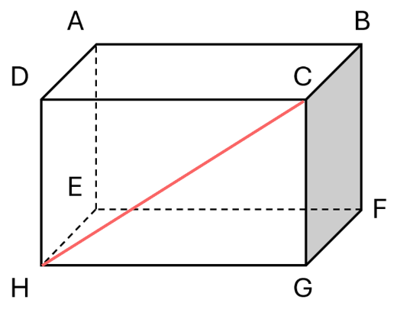
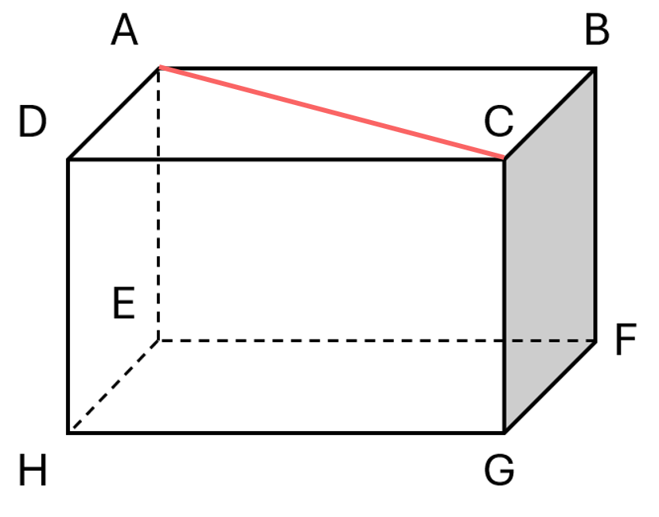
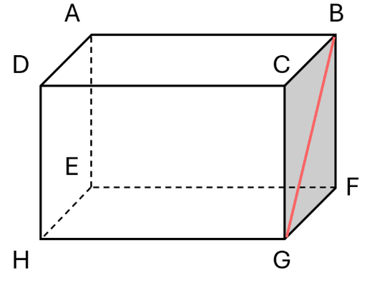
A face diagonal is a diagonal across a face of a 3D solid.

The face diagonal is the hypotenuse of a right-angled triangle, with both shorter sides being edge lengths of the prism.
To find the length of a face diagonal:
            - Draw a relevant right-angled triangle.
            - Calculate the length using Pythagoras’ Theorem.

- Example Calculate length of a face diagonal
Consider the rectangular prism below with lengths 4, 6, and 8 cm. Find the length of AC.
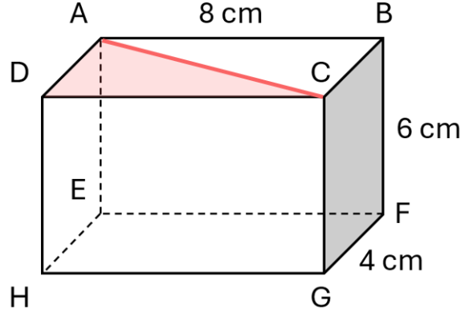 | 1. Triangle  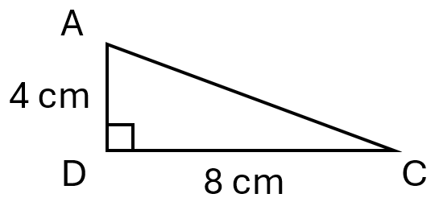 | 2. Pythagoras  $$AC=\sqrt{4^{2}+8^{2}} \\ =\sqrt{80} cm$$

- Guided Practice
Find the lengths of these face diagonals. Answer in exact form.
- $FH$  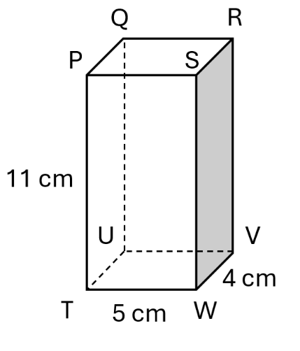  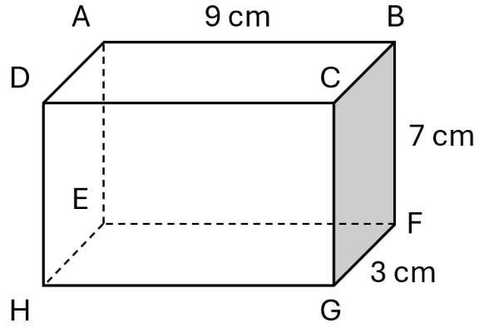  $\sqrt{90}$ cm | - $FA$  $\sqrt{130}$ cm | - $QT$  $\sqrt{137}$ cm
- Space Diagonal
A space diagonal is a diagonal through the interior of a 3D object.
- https://www.geogebra.org/m/mpnd5fck
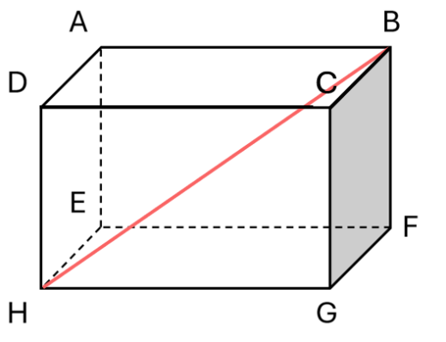
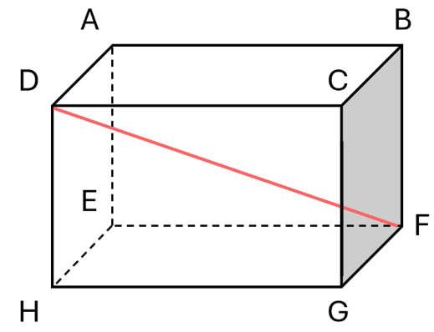
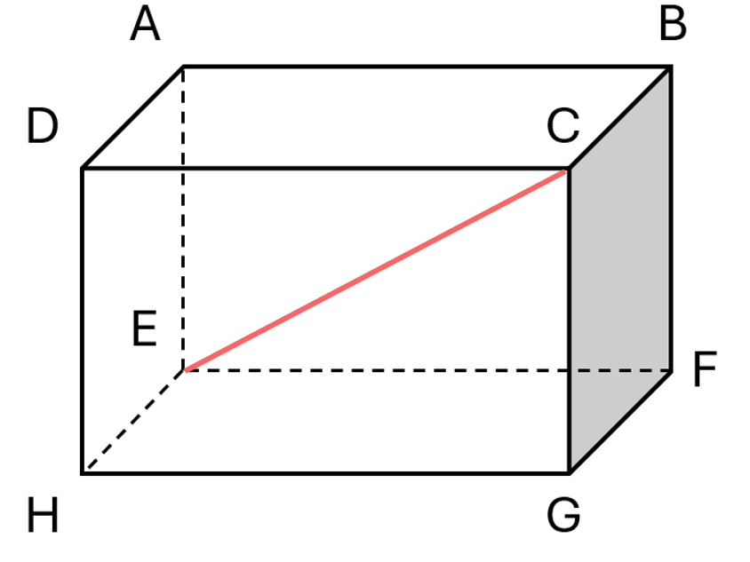

The space diagonal is the hypotenuse of a right-angled triangle, with one shorter side being the edge length of the prism, and the other shorter side being a face diagonal.
To find the length of a space diagonal:
- Draw two relevant right-angled triangles.
- Find the length of the relevant face diagonal. Keep it in exact value.
- Calculate the length of the space diagonal using Pythagoras’ Theorem.

- Example Calculate length of a space diagonal
Calculate the length of diagonal BH. Round your answer to 2 decimal places.
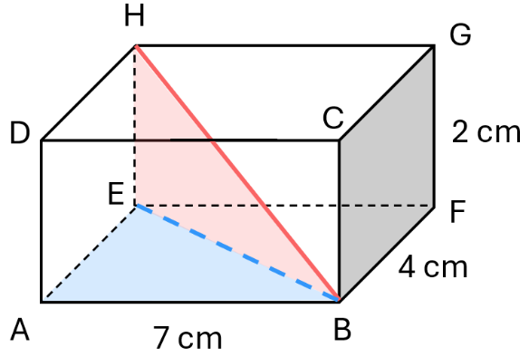
1. Triangles
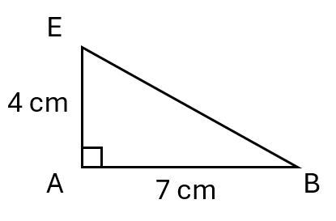
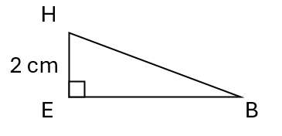

2. Face diagonal $EB$  $EB^{2}=4^{2}+7^{2}$  $EB=\sqrt{4^{2}+7^{2}}$  $=\sqrt{65}$ | 3. Space diagonal $BH$  $$BH^{2}=2^{2}+{\left(\sqrt{65}\right)}^{2}$$ $=69$  $BH=\sqrt{69}≈8.31$ cm

- Guided Practice
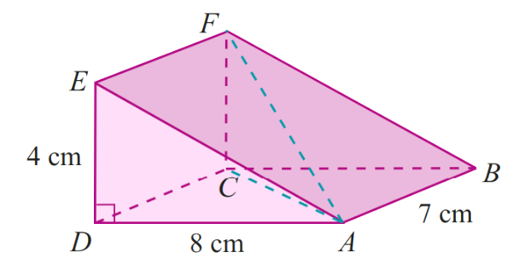  - Calculate the length $EB$.  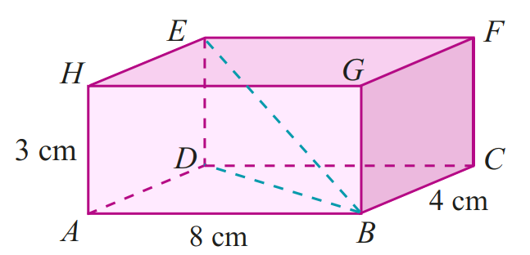  $\sqrt{89}$ cm | - Calculate the length $AF$.  $\sqrt{129}$ cm

Foundation
- In these questions you will only need to consider a single triangle. Find the value of $d$.
Answer to 2 decimal places.
11.18 mm | 0.34 m | 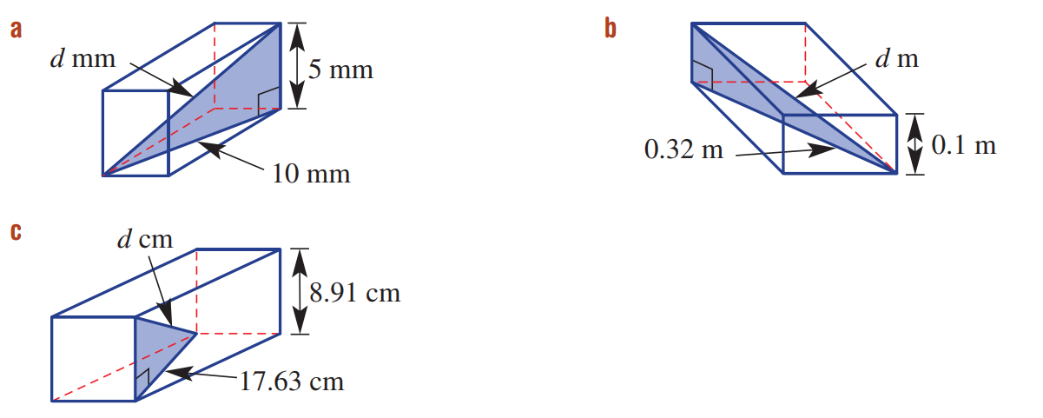  19.75 cm

- Calculate the slant height of these cones. Answer rounded to 1 d.p.
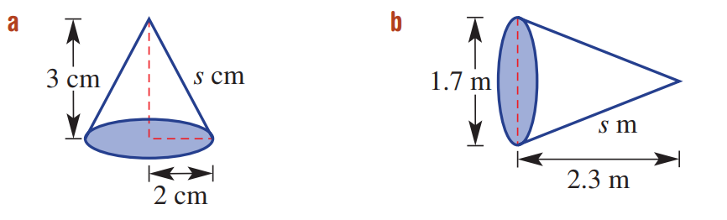  3.6 cm | 2.5 cm

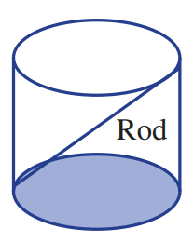
- Calculate the length of the longest rod that can fit inside this cylinder with a diameter of 10 cm and a height of 15 cm. Round to 1 d.p.

18.0 cm

Development
- For each of these rectangular prisms, first find BE, leaving your answer in exact form, then find BH, rounded to 2 decimal places. Draw and label the right-angled triangles you are using.
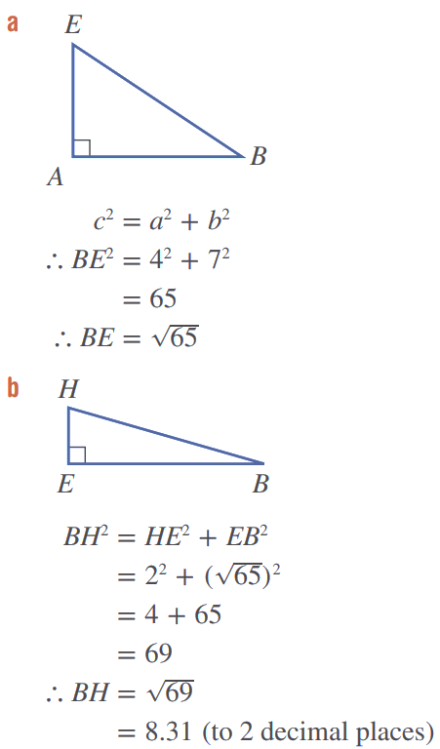
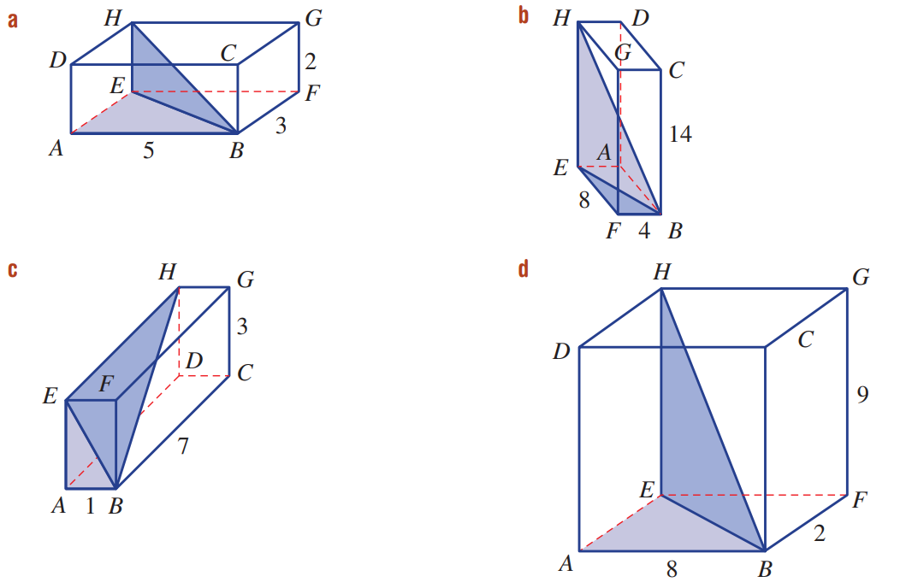

$$BE=\sqrt{34}, BH=6.16$$

$$BE=\sqrt{80}, BH=16.61$$

$$BE=\sqrt{10}, BH=7.68$$

$$BE=\sqrt{68}. BH=12.21$$

Mastery
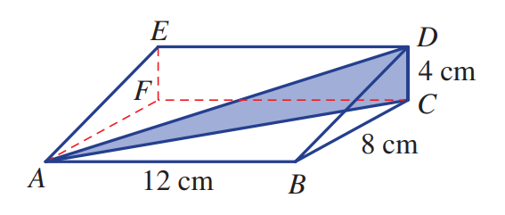
- Calculate the length of the diagonal AD, correct to 1 d.p.

15.0 cm
- Calculate the value of $x$ in each of these diagrams, to 2 decimal places.
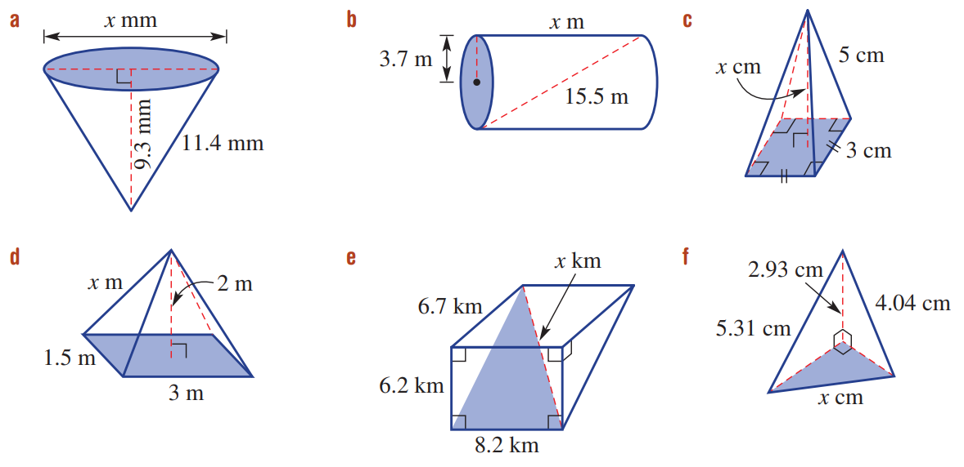  13.62 m | 4.53 m
2.61 m | 5.23 cm
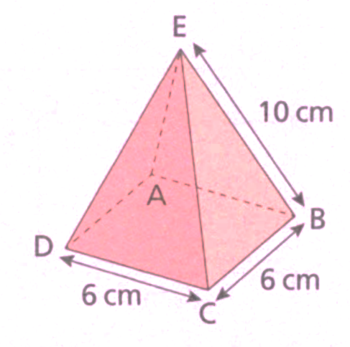
- Here is a square pyramid.
  - Work out the length of BD in exact form.

$\sqrt{72}$ cm
  - M is the midpoint of BC
    - Write the length of BM.
3 cm
    - Work out the length of EM, in exact form.

$\sqrt{{10}^{2}-3^{2}}=\sqrt{91}$ cm
    - Work out the perpendicular height of the pyramid, to 1 decimal place.

9.1 cm
- Here is a triangular prism.
Calculate these lengths, give your answers to 1 decimal place, where appropriate.
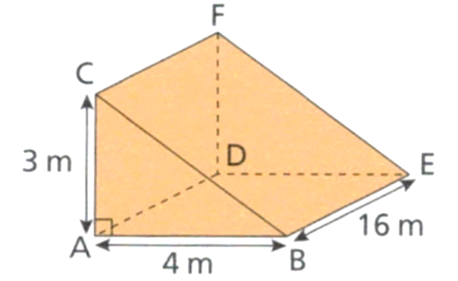
  - BC

5 m
  - AE

16.5 m
  - AF

16.3 m
- The diagonal of a cube measures 20 m. Calculate the following, rounding your answers to 1 d.p.
  - the volume of the cube
  - the surface area of the cube.

1539.6 m³, 800 m²

- There are different ways to approach finding the height of a pyramid depending on what information is given. For each of the following square-based pyramids, find the exact length of the diagonal of the base and the height of the pyramid to 2 decimal places.
Diagonal: $\sqrt{8}$ cm  Height: 3.74 cm | 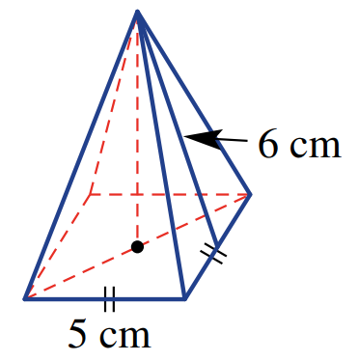  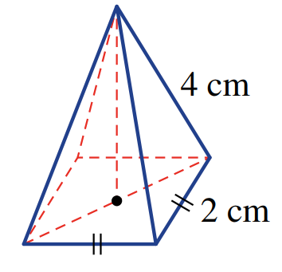  Diagonal: $\sqrt{50}$ cm  5.45 cm

3D Trigonometry

- Space Diagonal Angle Problems
Problems involving finding the angle of a space diagonal require trigonometry.
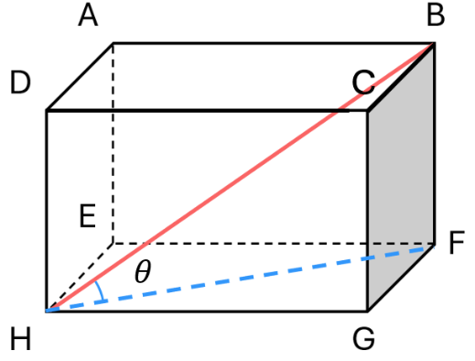

- Draw two relevant right-angled triangles.
- Find the length of the relevant face diagonal. Keep it in exact value.
- Calculate the angle using trigonometry.

- Example Find the angle of a space diagonal
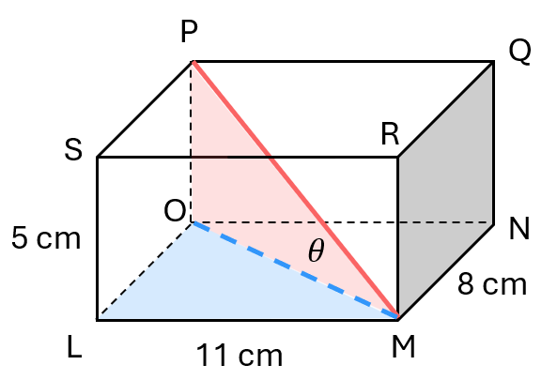
Find the angle that the diagonal $PM$ makes with the bottom face of the prism.
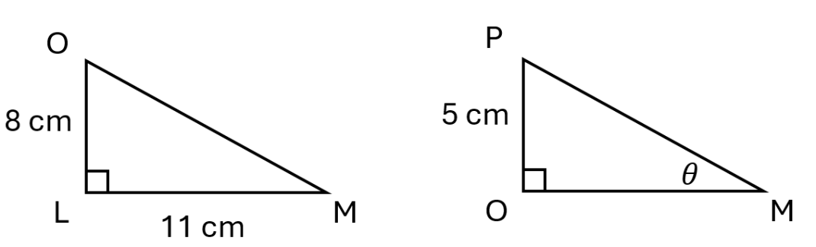
1. Triangles

2. Face diagonal $OM$  $OM^{2}=8^{2}+{11}^{2}$  $OM^{2}=185$  $OM=\sqrt{185}$ | 3. Find $θ$  $$\tan{θ}=\frac{5}{\sqrt{185}}$$  $$θ=\tan^{-1}{\frac{5}{\sqrt{185}}}$$  $=20°11'$

- Guided Practice
- Find $θ$ to the nearest degree.  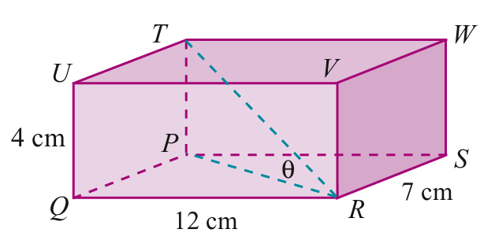  16° | 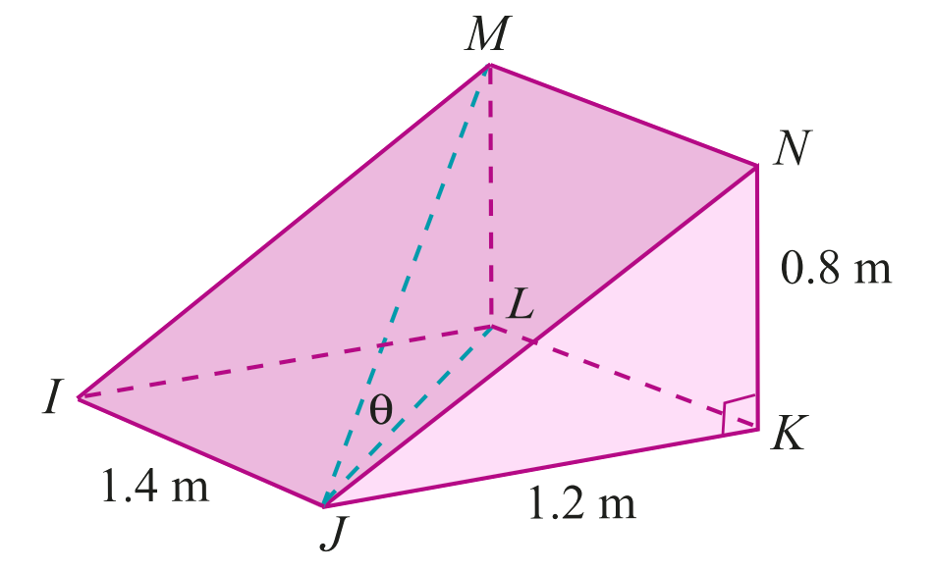  - Find $θ$ to the nearest degree.  23°

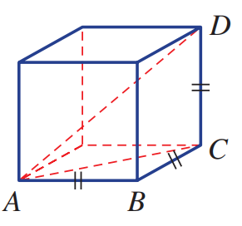
Foundation
- The cube shown here has a side length of 2 m.

- Draw the right-angled triangle $ΔABC$ and label all the side lengths.  Answer using exact values.  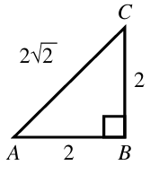 | - Draw the right-angled triangle $ΔACD$ and label all the side lengths.  Answer using exact values.  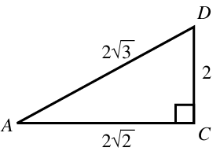
- Use trigonometry to find ∠DAC,
correct to 1 decimal place.

35.3°

- The diagram shows a rectangular prism.
  - Use Pythagoras’ theorem to find the length of the base diagonal BE.
  - Hence find the length of the prism diagonal BH.
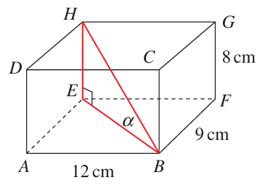
  - Find, correct to the nearest degree, the angle α that BH makes with the base of the prism.

a) 15 cm
b) 17 cm
c) 28°
- The diagram shows a triangular prism.
  - Find the exact length of:
    - AC
    - AF
  - What is the size of ∠ACF?
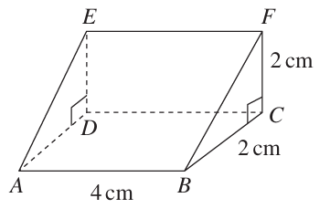
  - Find ∠AFC, correct to the nearest degree.

a) i) $2\sqrt{5}$ cm ii) $2\sqrt{6}$ cm
b) 90°
c) 66°

Development
- A ramp, ABCDEF, rests at an angle of 20° to the horizontal and the highest point on the ramp is 2.5 metres above the ground, as shown.
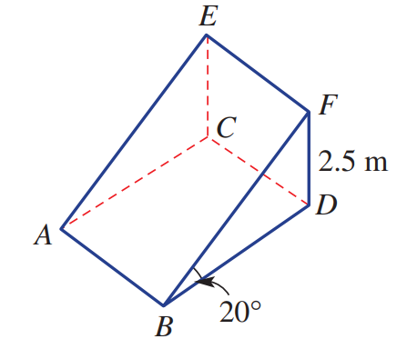
  - Find the length $BF$ to 2 d.p.

7.31 m
  - Find the length $BD$ to 2 d.p.

6.87 m
- The diagram shows a rectangular prism.
Find, correct to the nearest degree, the angle that the diagonal plane DBFH makes with the base of the prism.
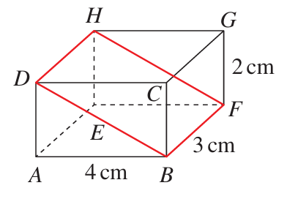

27°
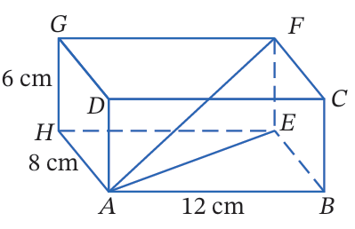
- Consider the rectangular prism. Calculate the angle $∠FAE$ to the nearest degree.

$$23°$$

Mastery
- The diagram shows a square pyramid.
The point C is the centre of the base, and TC is perpendicular to the base.
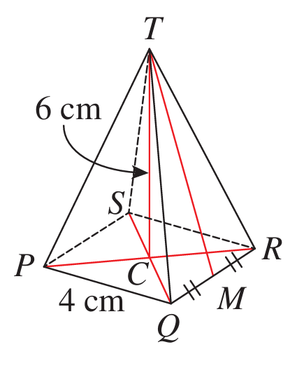
  - Write down the size of:
    - ∠CMQ
    - ∠TCM
    - ∠TCQ
  - Find the length of:
    - CM
    - CQ
  - Find, correct to the nearest degree:
    - The angle between a side face and the base.
    - The angle between a slant edge and the base.

a) i) 90° ii) 90° iii) 90°
b) i) 2 cm ii) 2√2 cm
c) i) 72° ii) 65°
- The diagram shows a square prism. The plane ABC is inside the prism, and M is the midpoint of the base diagonal BC.
  - Find the exact length of MD.
  - Hence find, to the nearest degree, the angle that the plane ABC makes with the base of the prism.
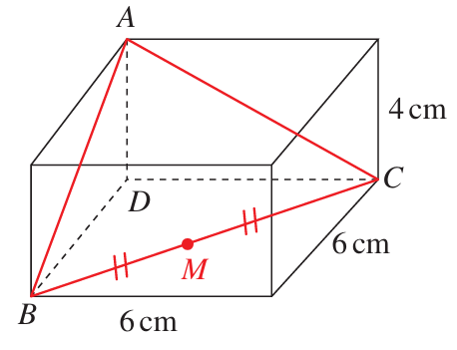

a) $3\sqrt{2}$ cm
b) 43°

3D Problems involving Trigonometry

- 3D Trigonometry Problems
For questions involving 3D trigonometry:
- Break down the scenario into 2D triangles.
- Bearings problems will require you to draw a top-down view.

- Example Solve problems involving 3D trigonometry
A 100 m flagpole is observed from 2 different locations.
From point A, due south of the flagpole the angle of elevation of the top of the flagpole is 35°; from point B, due east of the flagpole the angle of elevation is 22°.
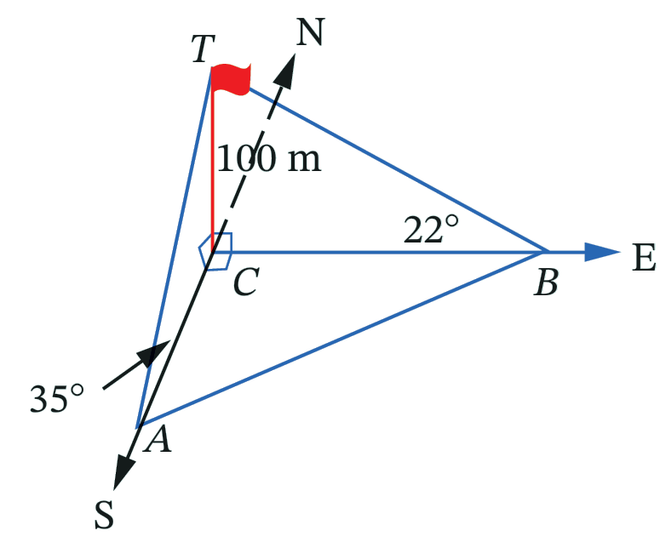
Find the distance between A and B, correct to the nearest metre.
2D triangles
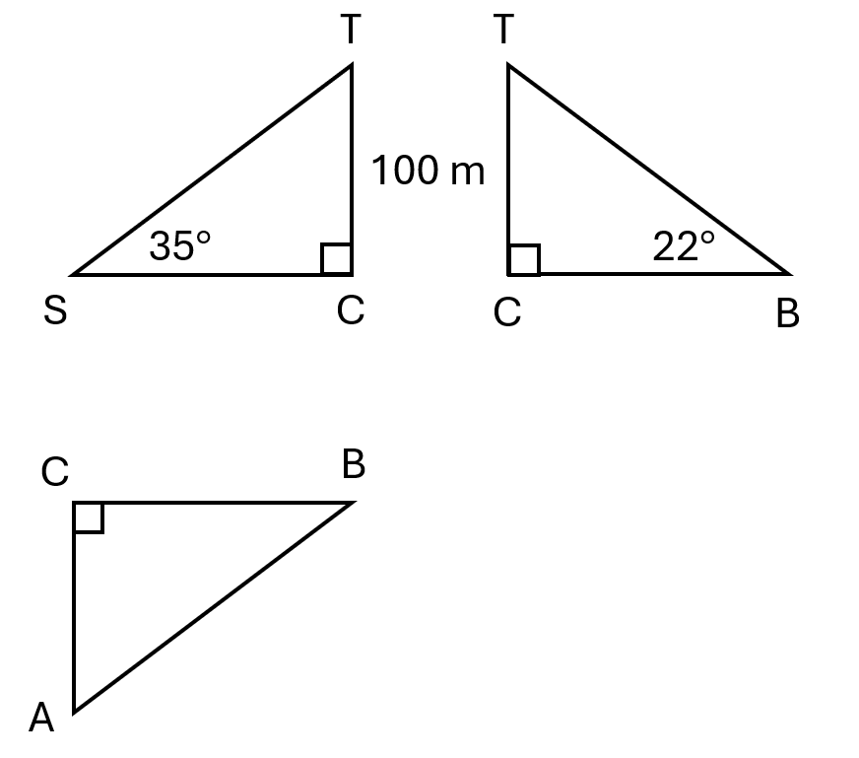

For AB: Find AC and CB first, then use Pythagoras
$$\tan{35°}=\frac{100}{AC}$$  $$AC=\frac{100}{\tan{35°}}$$ | $$\tan{22°}=\frac{100}{CB}$$  $$CB=\frac{100}{\tan{22°}}$$ | $$AB=\sqrt{AC^{2}+CB^{2}}$$  $$=\sqrt{\left(\frac{100}{\tan{35°}}\right)+{\left(\frac{100}{\tan{22°}}\right)}^{2}}$$  $≈286$m

- Guided Practice
From X, due south of a tower, the angle of elevation of the top of the 150 m tower is 28°.
From Y, due east of the tower, the angle of elevation of the top of the tower is 33°.
Find $d$, the distance between $X$ and $Y$, to the nearest metre.
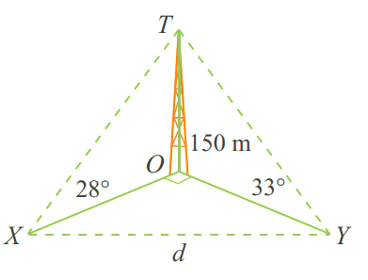

365 m

Foundation
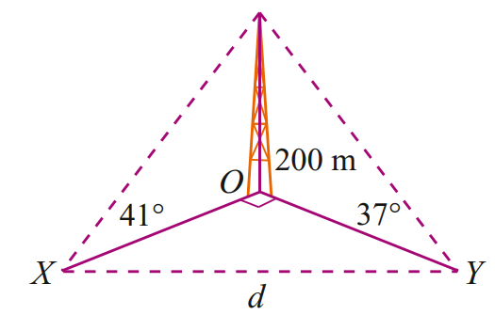
- From a point X due south of a tower 200 m tall on level ground, the angle of elevation of the top of the tower is 41°. From a point Y due east of the tower, the angle of elevation of the top of the tower is 37°.
$$Z$$
  - Draw and label $ΔZOX$
  - Draw and label $ΔZOY$
  - Draw and label $ΔXOY$and hence find $d$.

$$d=351 m$$
- Consider the diagram of a tent pole secured by two wires and pegs.
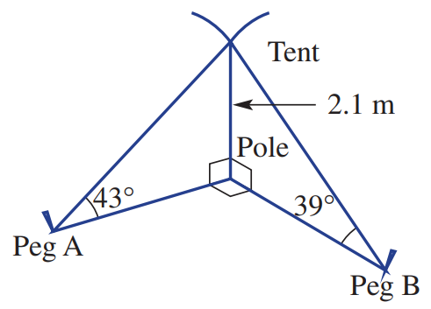
  - Find the distance from the base of the pole to peg $A$.

2.25 m
  - Find the distance from the base of the pole to peg $B$.

2.59 m
  - Find the distance between peg $A$ and peg $B$.

3.43 m
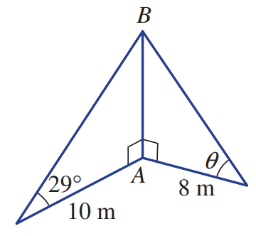
- For this 3D diagram, complete these steps.
- Find $AB$ in exact form.  $$10\tan{29°}$$ | - Find $θ$ to 1 d.p.  $$θ=\tan^{-1}\left(\frac{10\tan{29°}}{8}\right)=34.7°$$
  - Why is it important to keep values in exact form and only round the final answer?
Try finding $θ$ by rounding $AB$ to 1 d.p. and using the rounded result.
If you round too early your final answer will be inaccurate.
$$10\tan{29°}≈5.5$$
$$θ=\tan^{-1}\left(\frac{5.5}{8}\right)=34.5°$$
This answer is 0.2$°$ different to the answer without rounding.

Development
- The Great Pyramid of Giza is a square pyramid.
It has a perpendicular height of 280 royal cubits and a base length of 440 royal cubits.
Show that the apothem ($a$) is around 356 royal cubits and it has an angle of inclination of $52°$.
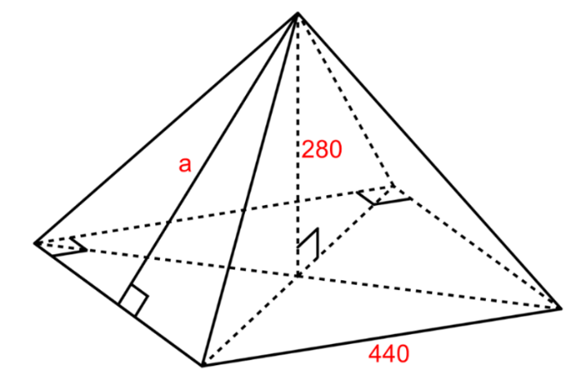

$$a=\sqrt{{280}^{2}+{220}^{2}}≈356$$
$$θ=\tan^{-1}\left(\frac{280}{220}\right)≈52°$$
- A tree BT is due north of an observer at P and due west of an observer at Q. The two observers are 50 m apart and the bearing of Q from P is 36°. The angle of elevation of T from Q is 28°.
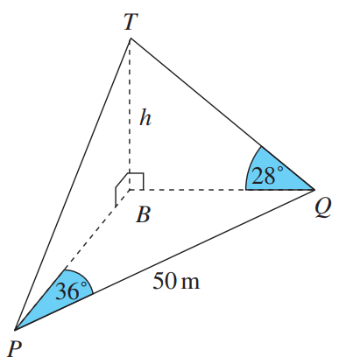
  - Show that BQ = 50sin36°.

$$\sin{36°}=\frac{BQ}{50}$$
$$BQ=50\sin{36°}$$
  - Hence find the height $h$ of the tree, correct to the nearest metre.

16 m
  - Find the angle of elevation of T from P, correct to the nearest degree.

21°
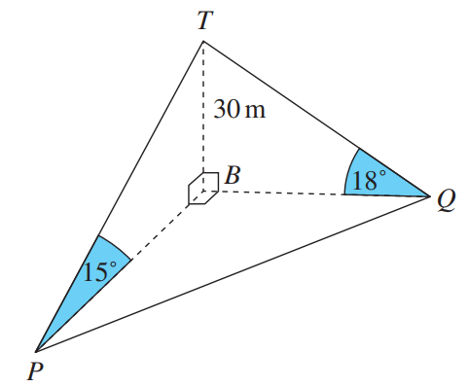
- Two landmarks P and Q on level ground are observed from the top T of a vertical tower BT of height 30m. Landmark P is due south of the tower, while landmark Q is due east of the tower. The angles of elevation of T from P and Q are 15° and 18° respectively.
  - Show that BP = 30 tan75°,
$$∠PTB=75° (angle sum of a triangle)$$
$$\tan{75°}=\frac{BP}{30}$$
$$BP=30\tan{75°}$$
  - Find a similar expression for BQ.

$$Similarly, BQ = 30\tan{72°}$$
  - Find, correct to the nearest metre, the distance between the two landmarks.

145 m

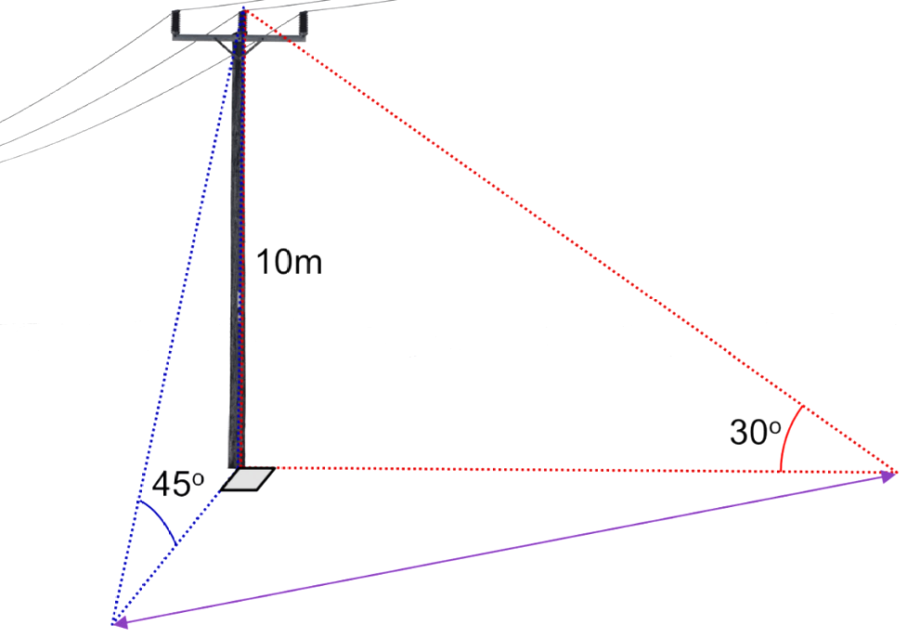
- Calculate the ground distance $x$.
$$x$$

20 m
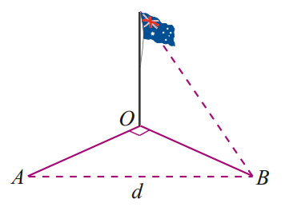
- From a point A due north of a flagpole 80 m tall on level ground, the angle of elevation of the top of the flagpole is 38°. From a point B due west of the flagpole, the angle of elevation of the top of the flagpole is 47°. Complete the diagram and calculate the distance AB to the nearest metre.

127 m
- Andrew (A) is on a bearing of 065° from a building which is 150 m tall.
Bret (B) is on a bearing of 155° from the same building.
The angle of elevation from Andrew to the top of the building is 42° while the angle of elevation for Bret is 61°. The land surrounding the building is level.
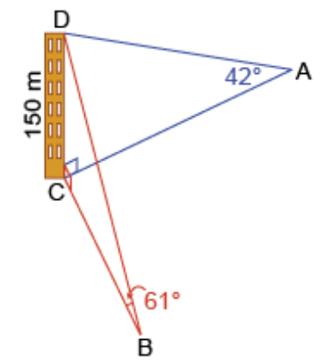
How far apart are Andrew and Bret, to the nearest metre?

$$AC=\frac{150}{\tan{42°}}, CB=\frac{150}{\tan{61°}}$$
$$∠ACB=155°-65°=90°$$
$$∴AB=\sqrt{AC^{2}+CB^{2}}$$
= 186 m
- A tree is 120 m tall.
From a point C due north on level ground, the angle of elevation of the top of the tree is 51°. From the point D due east of the tree, the angle of elevation of the top of the tree is 37°.
  - Draw a diagram showing this information.
  - Calculate the distance CD to the nearest metre.

187 m

Mastery
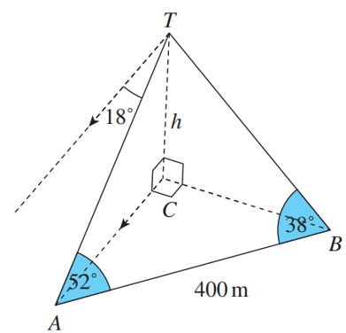
- Two monuments $A$ and $B$ are 400 m apart on the horizontal plane.
The angle of depression of $A$ from the top $T$ of a tall building is $18°$.
$∠TAB=52°$ and $∠TBA=38°$
  - Show that $TA=400\cos{52°}$
  - Find the height $h$ of the building, correct to the nearest metre.
  - Find the angle of depression of $B$ from $T$, to the nearest degree.

a) $∠ATB=180-52-38=90°$
$$\cos{52°}=\frac{TA}{400}, ∴TA=400\cos{52°}$$
b) 76 m
c) 14°
- A motorist on level ground sees, due north of her, a tower whose angle of elevation is 10°.
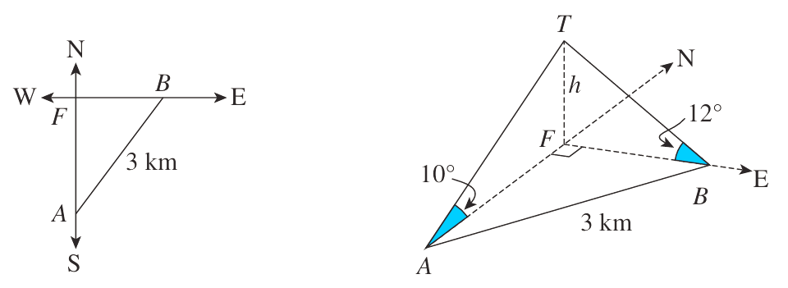
After driving 3 km further in a straight line, the tower is in the direction due west, with angle of elevation 12°.

In this question, no more than two measurements are known in any one of the triangles.
Therefore, we must introduce a pronumeral for the height, and work around until we have enough expressions in terms of $h$ such that an equation can be formed and solved.
  - Find an expression for AF.

$$\frac{h}{\tan{10°}}$$
  - Find and expression for BF

$$\frac{h}{\tan{12°}}$$
  - Use Pythagoras’ Theorem to form an equation using $h$, then solve for $h$ to 3 d.p.
$$AF^{2}+BF^{2}=AB^{2}$$
$∴h≈0.407$km
  - In what direction was the motorist driving?
Let $θ=∠FAB$, $\sin{θ}=\frac{FB}{AB}$
$$θ≈40°$$
she was travelling at a bearing of 040$°$
- From a point $P$ due south of a vertical tower, the angle of elevation of the top of the tower is $20°$.
From a point $Q$ 40 metres from $P$ and due east of the tower, the angle of elevation is $35°$.
$h$ is the height of the tower.
Show that $h=\frac{40}{\sqrt{\tan^{2}{70°}+\tan^{2}{55°}}}$ and evaluate $h$ to the nearest metre.
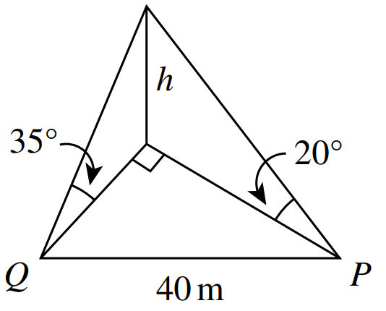

13 metres
- Two boats at sea are both observing the same lighthouse, which is at a height of 220 m above sea level. From boat A the bearing of the lighthouse is 040°T and the angle of elevation is 12°. From boat B the bearing of the lighthouse is 310°T and the angle of elevation is 17°.
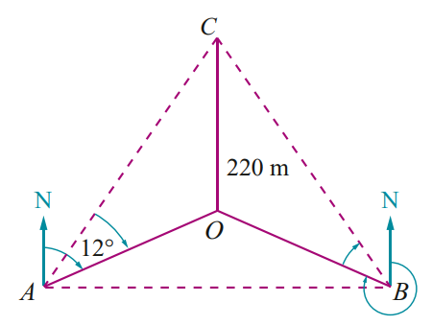
  - Complete this diagram.
  - Show that $∠AOB$ is $90°$(Hint: draw the top-down bearing diagram of $ΔAOB)$
  - Calculate the distances OA and OB and hence AB
  - Calculate $∠OAB$ and hence the bearing of boat B from A.

b) ∠AOB = (360° − 310°) + 40° = 90°
c) OA = 1035 m, OB = 720 m, AB = 1261 m
d) ∠OAB = 35°, bearing = 075°T
- Two boats at sea are both observing the same lighthouse, which is at a height of 520 m above sea level. From boat A the bearing of the lighthouse is 067°T and the angle of elevation is 15°. From boat B the bearing of the lighthouse is 337°T and the angle of elevation is 9°.
  - Calculate the distance between the boats.
  - Calculate the bearing of boat B from boat A.

a) 3814 m
b) 126°T
- Two boats are observed from a lighthouse 350 m above sea level.
Boat X is on a bearing of 138°T and at an angle of depression of 23°.
Boat Y is on a bearing of 228°T and at an angle of depression of 16°.
  - Calculate the distance between boat X and boat Y.
  - Calculate the bearing of boat Y from boat X.

a) XY = 1473 m
b) 262°T
- 2023 HSC Advanced Band 4
In the rectangular prism shown, AD = 7 cm, AE = 8 cm, EF = 6 cm.
Point M is the midpoint of CD.
Find ∠AEM to the nearest degree.
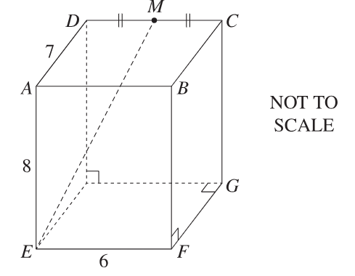
$DM = MC =\frac{1}{2}× 6 = 3$
$$In △ADM, by Pythagoras:$$
$$AM² = 7² + 3²$$
$$= 58$$
$$AM = \sqrt{58}$$
$$In △AEM:$$
$$tan ∠AEM =\frac{AM}{AE}$$
$$=\frac{\sqrt{58}}{8}$$
$$∠AEM = \tan^{-1}\left(\frac{\sqrt{58}}{8}\right)$$
$$= 43.59...$$
$$= 44° (nearest degree)$$

- HSC Sample Question Band 4
A tower TC is $h$ metres high.
At point A, due south of the tower, the angle of elevation to the top of the tower, point $T$, is 13°.
Point B is due east of the tower, with an angle of elevation to the top of 24°, as shown in the diagram.
Point A is 1.1 kilometres from Point B and both points are on the same ground level as the base of the tower, point C.
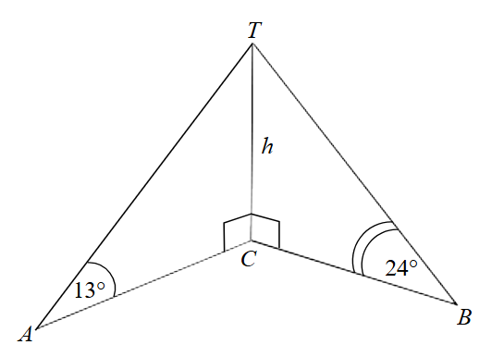

  - Show $BC = h × tan 66$°.
  - Find a similar expression for AC.
  - Hence, or otherwise, determine the height, h, of the tower. Give your answer correct to the nearest metre.

$$a) In △TBC ⇒ ∠CTB = 90 - 24 = 66°$$
$$tan 66° =\frac{BC}{h}$$
$$BC = h × tan 66°$$
$$b) In △TAC ⇒ ∠CTA = 90 - 13 = 77°$$
$$tan 77° =\frac{AC}{h}$$
$$AC = h × tan 77°$$
$$c) △ACB is right-angled (A due south, B due east).$$
$$By Pythagoras:$$
$$AC² + BC² = 1100²$$
$$h² × tan² 77° + h² × tan² 66° = 1100²$$
$$h²(tan² 77° + tan² 66°) = 1100²$$
$$h^{2}=\frac{{1100}^{2}}{\tan^{2}77° + \tan^{2}66°}$$
$$h = 225.44…$$
$$= 225 m (nearest m)$$

- The diagram shows a tower of height $h$ metres standing on level ground.
The angles of elevation of the top $T$ of the tower from two points $A$ and $B$ on the ground nearby
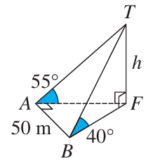
are 55° and 40° respectively.
The distance AB is 50 metres, and the interval $AB$ is perpendicular to the interval $AF$, where $F$ is the foot of the tower.
  - Find AT and BT in terms of $h$.

$$AT=\frac{h}{\sin{55°}}, BT=\frac{h}{\sin{40°}}$$
  - What is the size of $∠BAT$?

$90°$, as $AB$ is perpendicular to $AF$
  - Hence show that $h=$ $\frac{50\sin{55°}\sin{40°}}{\sqrt{\sin^{2}{55°}-\sin^{2}{40°}}}$
$$BT^{2}=AT^{2}+AB^{2}$$
$$\frac{h^{2}}{\sin^{2}{40°}}=\frac{h^{2}}{\sin^{2}{55°}}+{50}^{2}$$
$$\frac{h^{2}}{\sin^{2}{40°}}-\frac{h^{2}}{\sin^{2}{55°}}={50}^{2}$$
$$\frac{h^{2}\sin^{2}{55°}-h^{2}\sin^{2}{40°}}{\sin^{2}{40°}\sin^{2}{55°}}={50}^{2}$$
$$\frac{h^{2}\left(\sin^{2}{55°}-\sin^{2}{40°}\right)}{\sin^{2}{40°}\sin^{2}{55°}}={50}^{2}$$
$$h^{2}\left(\sin^{2}{55°}-\sin^{2}{40°}\right)={50}^{2}\left(\sin^{2}{40°}\sin^{2}{55°}\right)$$
$$h^{2}=\frac{{50}^{2}\left(\sin^{2}{40°}\sin^{2}{55°}\right)}{\left(\sin^{2}{55°}-\sin^{2}{40°}\right)}$$
$$∴h=\frac{50\sin{40°}\sin{55°}}{\sqrt{\sin^{2}{55°}-\sin^{2}{40°}}}$$

